

Driving Higher Levels of Workforce Retention and Engagement
Through a
Workplace Financial Well-being Program
by
H. Glenn Carnathan, Jr.
President & CEO

Introduction
Virtually every employer in the U.S. is seeking to adapt to an increasingly challenging set of workforce dynamics. With four distinct workforce generations (all possessing differing value sets), multiple ethnic groups, and the predominance of dual-income families, employers often struggle with offering a comprehensive employment proposition and programs that are effective within all segments of their workers – especially when it comes to driving higher levels of workforce retention and engagement. An approach that works for one set of demographics usually is not very effective with others. It is rare, yet extraordinarily valuable, when a single effort can have equal power and effectiveness across all workforce demographics. What this article will show is how an employer workplace financial well-being program can have that effect – while driving higher levels or workforce engagement.

For purposes of this article, a thoroughly engaged employee is defined as one who:
- Is excited and enthused
- Forgets about time
- Expends discretionary effort, i.e. the manifestation of:
  - Insight
  - Originality
  - Intuition
  - Judgment
  - Humor
  - Inspiration
  - Leadership
  - Friendship
- Identifies with the task
- Thinks about the “question” outside of work hours (e.g., when driving home)
- Resists distractions
- Invites others into the work and engages others (emotional contagion)

The issue of dis-engagement is that employers often do not see it. Dis-engaged employees tend to “fly under the radar.” Their goal is to get by, not rock the boat, and hang on. In addition to the obvious organizational impacts of dis-engagement is the cost of lost recruits, employees, and customers.

The article is organized as follows:

- The Detrimental Impact of Personal Financial Dissatisfaction/Distress on Employers
- Some Compelling Research Articulates this Reality
- The Strong Correlation between Employee Engagement and Business Outcomes
- The Impact of Well-being on Organizational/Workforce Vitality
- The Negative Impact of Financial Dissatisfaction/Distress on Critical Workforce Retention and Engagement Factors
- The Surprising Power Financial Well-being has on Workforce Engagement
- How and Why an Effective Workplace Model works
- Summary of Organizational Benefits

The Detrimental Impact of Personal Financial Dissatisfaction/Distress on Employers
Very recent national research reveals that, in any workforce, on any given day, a significant portion of that workforce will be dealing which personal financial issues so critical that they severely and negatively impact both their personal and professional lives. For employers, this has very significant cost, operations and quality implications.

Another major portion of any workforce may not be in severe financial distress – but are working multiple jobs and/or extra shifts, just to make ends meet. They may be “getting by” financially, but both their personal and professional capacity is limited. On the personal front, this group feels like they’re missing out on family time, experience and presence that cannot be recovered. This is such a prevalent issue that the most significant request of two-wage earner families is “how to become a single wage earning family!”

Still others in any workforce may feel like they have their current finances under control, but have no idea how to go about planning for their financial future. With almost no financial education in our schools, families and houses of worship, people enter their adult lives with no roadmap for preparing for both today and tomorrow…whether it’s planning for a child’s future, or knowing how and when to start preparing for longer term financial goals. The result, a major segment of any worker population will tell you that they are dealing with matters related to their personal finances to the extent that their sense of personal well-being (both at work and at home) is diminished.

In a culture where (rightly or wrongly) people are defined by what they earn and what they own, there is often a stigma associated with talking openly about personal financial issues. This is why many employers and their leaders are often surprised by the information regarding the prevalence of personal financial dissatisfaction or distress in their workforce. In reality, personal financial issues are actually the number one cause of stress and is the most prevalent need presenting to Employee Assistance Programs across the U.S.

The impact of this reality is seen within organizations in the following areas:
- Attendance, Tardiness, and Overtime
- Turnover
- Productivity
- Cost of worker and family distress
  - Healthcare claims
  - Sick and Disability claims

When people are pulling extra hours or working multiple jobs just to make ends meet or to keep the collectors away, attendance and tardiness problems increase. Their inability to be flexible regarding work schedules in their teams often leads to overtime of others – to say nothing of team morale issues. Workers who are dissatisfied or distressed with their personal finances are much more likely to leave you just to make a nickel more an hour. The attempt to retain workers through a comprehensive employment proposition is a failed exercise with these workers as they typically do not understand or appreciate their personal value. When workers are struggling financially they will be less productive – and typically disrupt the productivity of others as well. Of paramount importance to employers is the impact of personal financial distress on healthcare, sick pay and disability costs. In addition to the “stress” impact of financial distress, affected employees are often forced to make decisions against appropriate medications, regular physician check-ups, eating the right foods, getting the right exercise, etc. The author has a simple ROI modeler that was developed to show the senior financial executives of the nation’s largest not-for-profit health system just how profound this effect can be – and what a significant ROI it can generate. Using very conservative assumptions, the modeler suggests a tangible productivity ROI of $250 to $750 per employee per year, net of any program costs. For a 1,000 employee population, this would result in an ROI in the range of $250,000 to $750,000!

Some Compelling Research Articulates this Reality
The following illustrates the prevalence and impact of personal financial distress.
The Number One Source of Stress is Personal Financial Concerns:

Here are some other eye-opening research findings:
- 90% of U.S. Workers are dissatisfied with their Personal Finances
- 67% of U.S. Workers (regardless of income, education, or position level) are dealing with Personal Financial Issues
- 25% of U.S. Workers are seriously financially distressed - causing negative impacts on individuals, families, and employers

Taking a deeper look at this last research reference, we found that, not only is the problem prevalent – it is much more critical at lower income levels.

Household Income | Range of Levels of Financial Distress
Less than $14,999 | 80% to 90%
$15,000 - $24,999 | 70% to 80%
$25,000 - $34,999 | 50% to 60%
$35,000 - $49,999 | 30% to 60%
$50,000 - $74,999 | 30% to 50%
$75,000 - $99,000 | 20% to 30%
$100,000+ | 9% to 25%
All Income Groups | 25% to 60%

For a 5-hospital health system in Nashville TN, at which the author was the Senior Vice President and Chief Human Resources Officer, it was expected that 33% to 44% of workers were financially distressed – based on the level of family income reported in a financial well-being assessment tool associated with the workforce employee survey.

The Strong Correlation between Employee Engagement and Business Outcomes
The above information and reality becomes critical to an organization when it is viewed in the context of the business case for driving workforce engagement. This brief section highlights some outstanding work by Towers Perrin, an international human resources research and consulting firm. Two recent case studies do a very good job at connecting the dots between employee engagement and the key desired outcomes, as illustrated below:

Case Study #1

Case Study #2

The Impact of Well-being on Organizational/Workforce Vitality
The following graphic illustrates the “structure” of any culture, whether it’s the Incan culture, General Electric, or your organization. Well-run companies do a pretty good job at structuring themselves for 4 out of the 5 key factors – but most organizations fail at understanding the role of well-being in predicting the vitality of their workforce.
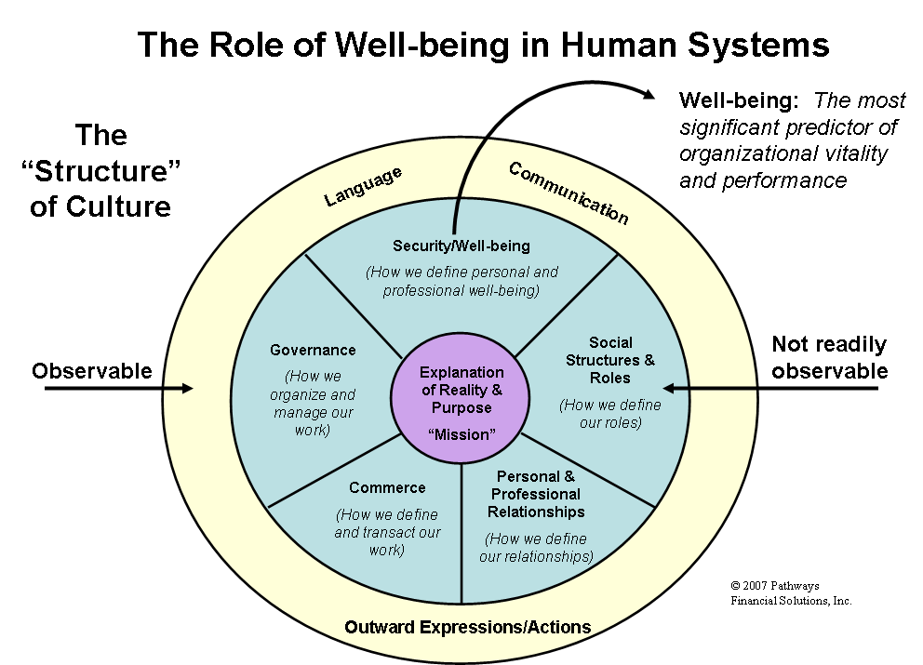

By focusing on the drivers of personal and professional well-being (which include personal financial well-being), organizations can make significant strides in increasing both the capacity and willingness of their employees to engage their work, their teams and their employer’s mission!

The Negative Impact of Financial Dissatisfaction/Distress on Critical Workforce Retention and Engagement Factors
Given the foregoing, let’s begin to connect the dots between financial dissatisfaction and distress on three key factors critical to high levels of workforce retention and engagement. They are:

- A positive mindset
- A healthy view of management, and
- A healthy connection to their work

The author shared this following illustration at two Federal Reserve Bank business leader conferences focused on the efficacy of employer-based financial well-being programs. The illustration takes the research noted earlier in this article and overlays it with the three above factors from workforce research that predict the capacity and likelihood for employees to fully engage their work, their teams and their employer’s mission.

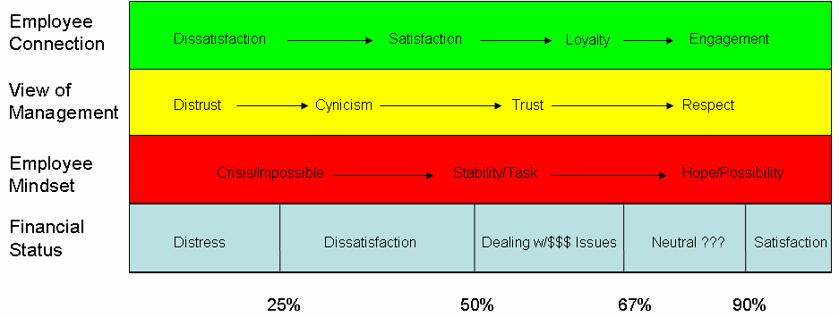

The CEOs, CFOs and others leaders in attendance truly connected with the certain impossibility that financially dissatisfied or distressed employees will (1) have a forward-thinking/possibility mindset, (2) trust and respect management, and (3) manifest desired loyalty and engagement attributes.
At the same Federal Reserve Bank conferences, the business leaders were asked to consider their key workforce investments (Direct Pay, Traditional Benefits, Development Programs, and Work-life Programs), and then to evaluate their desired versus actual outcomes of those investments.

In a similar fashion to the first illustration, the leaders all agreed that a major segment of their workforce would be better described by the Actual Outcomes column than the Desired Outcomes column.

The Surprising Power Financial Well-being has on Workforce Engagement
Ok, so much for the discouraging current reality. There is hope…practical, sustainable and affordable hope.

Earlier, the impact of well-being on organizational vitality was discussed. Below is yet another research jewel from Towers Perrin.

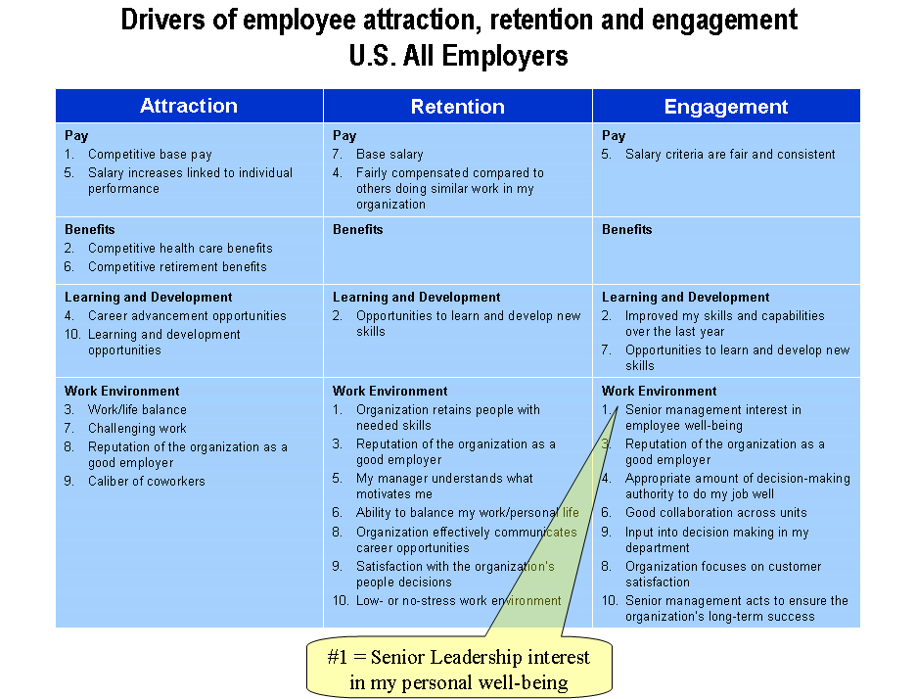

This slide reflects a summary of what Towers Perrin found to be the key drivers of attraction, retention and engagement across all U.S. industries. If you think about the drivers of retention and engagement, you see that many of the Learning and Development and Work Environment factors can be positively impacted through an effective workplace financial well-being program. It is important to note that Towers Perrin found the most powerful driver of employee engagement to be senior leadership interest in employee well-being. In the author’s approach to workplace financial well-being, both senior and front-line leaders are positioned as the champions and advocates of employees through this initiative so that employees come to associate their improved personal well-being with them. Does it work in real life? Yes!

In a 10,000 employee group, a full-service workplace model was implemented and measured through an employee survey with a contiguous financial well-being assessment tool. Shortly after program implementation in 2003, the leaders of that organization were surprised to see the prevalence and depth of personal financial reality on their employees’ personal and professional lives. In this survey, the employees indicated that their personal financial acumen, disciple and situation were negatively impacting their job and their family. On a four-point scale where 1 was the most negative impact and 4 was the most favorable, the average score was 1.2 – the lowest scoring segment of the entire financial well-being assessment. Interestingly, this result was consistent across all income and education levels – validating Neil Cutler’s findings mentioned earlier in this article.

Fast forward two years to 2005. Not only did the survey reveal improvements in personal financial awareness and well-being – an indication of improved financial behaviors – a more powerful result was revealed. Using a statistical method called factor analysis to discern the drivers of workforce engagement, basic financial well-being proved to be the 4th most powerful driver of engagement out of the 18 factors in the combined employee survey and financial well-being assessment tool. What impressed that organization’s leadership was that financial well-being (which was costing virtually nothing through their delivery model) scored ahead of areas in which they were investing huge organizational resources (e.g. Compensation & Benefits, Manager Effectiveness, Staffing and Resources, etc.). The conclusion: the ROI and effectiveness of this model was “low hanging fruit” – and was (and is) consistently effective across all workforce demographics!

So, how does a workplace financial well-being model produce such effective results?

How and Why an Effective Workplace Model Works
One of the author’s favorite sayings is the Penzias Axiom. Arno Penzias was an engineer who, in the 1950s, predicted today’s employee self-service model when he said:

Anything that comes between the customer and the computer system…

that will not completely fulfill his request (i.e. does not add value!!!)…

will be removed.

Unfortunately, as “things” have been removed between the computer and the individual, many factors that do add value have been removed as well. This is why most online/telephonic delivery models are not producing results that reflect individual engagement and behavior change – much less desired workforce outcomes.

At the heart of an effective workplace model are key principles related to adult learning, engagement and behavior modification; specifically the fact that:

- People still need a personal touch - The internet alone or periodic lunch and learn sessions simply do not produce employee engagement – much less changed behaviors.

- Adults learn and change behaviors though “doing” – and doing things driven by need.

- People need to be met “where they are.” – Once engagement occurs (and only then) most people will access services (e.g. internet, phones, lunch and learns) outside of their normal routine/behavior patterns.

The author has experimented with various approaches over his 30 years of practice and has concluded that:

- People simply do not respond to offers of broad-based or “generic” offers related to personal financial matters. This is why many employers who have dabbled with financial well-being efforts will tell you, “We tried it and it didn’t work.” or “We built it and they didn’t come.” Why is this?

- Because of the lack of effective personal financial education within schools, families, etc., most people across all income or education levels are simply overwhelmed or intimidated by knowing where to start – and will usually not seek to fit this into the other demands and priorities of their lives as a result.

- By meeting people where they are (at work – and focusing on specific personal needs that are important to the individual) people will respond – especially when they believe that this is important to and valued by their supervisor and leaders. By leading with a focus on addressing specific personal needs (instead of the “offer” of financial education or planning services), the initiative connects with individuals at the affective level – which then drives engagement with the more cognitive aspects of personal financial management.

- As specific personal needs are met with success, then other areas of personal finances will be engaged. Additionally, individuals will share their personal results with others which will drive higher levels of participation by others.

- Positive and powerful workforce outcomes result – and produce those effects in a surprisingly short time frame as noted earlier. The positive impact of improved personal financial well-being on traditional workforce measures (e.g. attendance/tardiness, productivity, etc.) is not the only result. For many people, reducing financial dissatisfaction or distress can have a positive impact on overall health – which reduces health, sick and disability claims. And, as noted earlier, driving higher levels of personal financial well-being drive higher levels of workforce engagement.

Summary of Organizational Benefits
As an effective workplace financial well-being model is implemented, the following outcomes can be expected. The organization will:
- Tap into multiple drivers of retention and engagement, e.g.:
  - Leadership interest in personal well-being
  - Opportunity to learn, grow and advance
  - Reputation of the employer
  - Retaining high caliber people
  - Decision-making and input
  - Satisfaction with pay and benefits – meeting one’s personal needs

- Offer something that is equally important to and highly effective within every possible demographic in a highly diversified workforce, e.g.:
  - Generational
  - Gender
  - Ethnicity

- Realize desired operational and fiscal outcomes:
  - Increased productivity and efficiency
  - More stable and engaged workforce
  - Improved customer retention and loyalty
  - Lower operating expenses
  - Improved profitability

- Find the initiative easy to implement and sustain – with financial service providers doing the “heavy lifting.”
  - Senior Leaders simply advocate for the program and hold managers accountable for engagement
  - Front line managers advocate for employees through engagement of onsite service providers in operationally sensitive manner.

There are several approaches to operationalizing an effective workplace financial well-being model in your organization. If this overview has piqued your interest, please do not hesitate to contact Pathways Financial Solutions.

H. Glenn Carnathan, Jr.
President & CEO
Pathways Financial Solutions, Inc.
7445 Lake Blvd., Suite 100
Spanish Fort, AL 36527

251-581-3461
glenn.carnathan@pathwaysfinancial.com

2004 The Concours Group: Re.sults Project EMP: Excelling at Employee Engagement
2002 – Center for Financial Well-being
2002 – Center for Financial Well-being
2004 Employer/Employee Equation Research on Worker Types, Preferences and Engagement Issues – Concours Group, Age Wave and Harris Poll, 1997 Neal E. Cutler, Ph.D.
2005 Final Report: 30 Million Workers in America—One in Four—Are Seriously Financially Distressed and Dissatisfied Causing Negative Impacts on Individuals, Families, and Employers – E. Thomas Garman, Glenn Carnathan, et al
2003 STHS Associate Survey with Financial Well-being Assessment
2003 Talent Report: New Realities in Today’s Workforce – Towers Perrin
2005 Workforce Study — United States – Towers Perrin

